Date last revised: May 22, 2020

Some Economic Impacts of Changing Population Age Distributions—Capital, Labor and Transfers

Ronald Lee  
Departments of Demography and Economics  
University of California  
2232 Piedmont Ave  
Berkeley, CA 94720

E-mail: [rlee@demog.berkeley.edu](mailto:rlee@demog.berkeley.edu)

This paper was updated and revised for the virtual NTA13 meetings. I am very grateful to Gretchen Donehower for help with the calculations, to Andrew Mason for many discussions of the issues covered in this paper, and to Ivan Mejia and the Swedish NTA team for the use of their NTA data. I am also grateful to all the NTA country teams for use of their estimates. These researchers are identified and more detailed information is given on the NTA website at: [www.ntaccounts.org](http://www.ntaccounts.org).

Some Economic Impacts of Changing Population Age Distributions—Capital, Labor and Transfers

Abstract

How does a change in the population age distribution affect the macroeconomy? Starting from a standard growth model setup and an initial population age distribution, I consider the consequences of an arbitrary but small perturbation of the full age distribution, which could reflect population aging, or a demographic dividend, or a baby boom, or comparative steady states. Holding the shapes of age profiles from National Transfer Accounts constant, the age distribution perturbation affects aggregate labor supply, capital, consumption, and saving. Assuming a Cobb-Douglas production function, I derive effects on National Income, per capita income, wages, interest rates, and so on. The impact on consumption per effective consumer comes closest to a welfare outcome measure, and implicitly reflects the systems of public and private transfers. Results are derived for both open and closed economies. Applications to the US and other rich and developing nations show that results can be quite different than the support ratio suggests, and that effects of population aging on individual economic well-being can be muted or reversed because of rising capital intensity.

# Introduction

The demographic transition has brought dramatic changes in population age distributions, giving some countries demographic dividends, and others the challenges of population aging. In some cases, baby booms and busts add fluctuations on top of these long run age distribution changes. What are the economic consequences of these changes? Support ratios capture the main effect simply and intuitively, but have limitations. Here I will develop an approach that reflects the demographic linkages to labor, capital, consumption and saving, through age profiles from National Transfer Accounts (NTA) (Lee and Mason et al, 2011; United Nations, 2013; ntacounts.org). I consider how an arbitrary perturbation of the initial population age distribution, as mediated by these age profiles, affects economic outcomes based on a simple economic model.

Small perturbations in the neighborhood of some initial state have two kinds of effects. First, there is the effect of changing population age distribution holding the age profiles constant, and second there is the effect of age distribution change on the age profiles, holding the initial population age distribution constant. Of course, these age profiles will most likely change in various ways in the future, but only those changes caused by changes in the population age distribution are relevant here. In this paper, I will ignore these and focus on the first kind of effect. For example, I will not consider the possibility that a decrease in the size of one age group might cause the labor income of its members to rise. Nor will I consider the possibility that the rising survival that leads to more old people also delays the bequests received by their children and thereby alters the age profile for asset income. Nor that population aging may lead to changes in public transfer systems.

Although changes in the shapes of the age profiles will not be incorporated here, changes in their levels will be modeled and assessed. Changing population age distributions will alter the relative abundance of labor and of capital in the aggregate economy. In an open economy, this would not affect wages and interest rates, but in a closed economy it will, and these effects can be incorporated using a simple production function setup. Such feedback effects are particularly relevant here, because they modify the implications of the support ratio analysis. If labor grows more rapidly, as during the demographic dividend phases, then capital per worker may fall, reducing productivity growth. If the elder population grows more rapidly, it will bring more capital and perhaps boost the wages and productivity of labor, while reducing interest rates. Such changes figure prominently in many economic analyses of the consequences of population aging, and this approach offers a partial equilibrium quantification.

The analysis has been applied to many NTA countries. Here I will emphasize results for the US, but also present estimates for other rich countries and some developing countries at different stages of the demographic transition.

# NTA Age Profiles

Details concerning the estimation of the age profiles can be found in the NTA manual (United Nations, 2013). Here I will give a brief outline. The estimates are based on existing surveys and administrative data, particularly household income and expenditure surveys and the System of National Accounts (SNA) for each country. Profiles are averages across all population members of a given age, regardless of whether male or female, or whether values or zero, positive or negative. Age profiles are multiplicatively adjusted so that when multiplied by population age distributions and summed, the SNA total for each item results. Labor income includes wages, salaries and fringe benefits, plus the labor share of self-employment income and unpaid family labor. Consumption is estimated from each household’s consumption expenditures which are then imputed to individual household members using equivalent adult consumer weights, except for health and education expenditures which can typically be assigned to individuals based on the surveys. Asset income includes the imputed value of housing services from owned homes as well as income from financial investments. Saving includes the retained earnings of corporations which are allocated to the individual stock holders based on asset earnings.

Figure 1 shows the baseline age profiles for the US (in 2007, just before the Great Recession) and five other countries. For the US, similar estimates are available annually since 1981 through 2011, and less completely for 1961. Some features of these profiles will be discussed later. Similar data are available for more than fifty countries (but often for only one calendar year) and for many countries these data can be accessed at ntaccounts.org. The NTA project is decentralized, with 50 member research teams in countries around the world.

# Modeling the Economy

Consider a closed economy, and for simplicity (but with straightforward generalizability) assume there is no technological progress. For a NTA base year in some country, let  be the average amount of labor inelastically supplied by members of the population age x, measured in efficiency units. This includes selfemployed labor and unpaid family labor. Let w be the wage per efficiency unit of labor, and in the NTA baseline year let this wage be . Then the observed NTA labor income profile is , in monetary units.

Similarly, let  be the average amount of capital held by members of the population at age x and inelastically supplied, measured in efficiency units. Let r be the rate of return earned per efficiency unit of capital (the interest rate), equal to  at NTA baseline year. Then the observed NTA asset income profile is [1]. In NTA we typically observe asset income rather than the stock of assets or capital, but the average stock  can be estimated as [2]. In the present context it is the age shape of  that matters in, not its level. The key assumption here is that there is a single rate of return r that applies to assets held by people at all ages x. If older people invest more conservatively and earn a lower rate of return than younger people, this assumption will be wrong, and this point should be investigated.

Let *P(x,t)* be the number of people in the population at age x in year t. The aggregate labor supplied in year t, denoted *L(t)*, is given by the sum or integral of *P(x,t)* times labor measured in efficiency units , that is (with time suppressed for notational simplicity):



Capital stock is expressed similarly:



The aggregate amounts of labor and of capital generate aggregate output Y according to the constant returns to scale aggregate production function:



Labor income is  and capital income or asset income is . The factor returns w and r are assumed to equal the marginal products of labor and capital derived from .

For open economies, I assume that labor is immobile and that capital flows in or out of the country so as to set the wage and interest rate to the levels determined by international markets. In this case, K in the production function may be larger or smaller than the K supplied by the domestic population, and national income can differ from total output, Y. Mobile labor could be incorporated but would complicate the story.

## Population Age Distributions

Let the initial population age distribution at NTA base year be  where x is age and time t is suppressed. Consider a small perturbation of this population age distribution by an amount , where  is a multiplier determining the size of the perturbations and  describes the age pattern of the changes which may be positive or negative at a given age, and which will sum to the change in the total population size. The new population with the perturbed age distribution is then given by:



This formulation enables us to describe the size of changes in age distribution by the single parameter  which makes it easy to use calculus.

As an example, let u(x) be the actual change in population at age x from 2015 to 2016. Then . . When =0 we get . When  we get . When  is between 0 and 1, the age distribution is correspondingly interpolated between that of 2015 and 2016.

For another example, let  be a proportional stable population age distribution. Associated with some life table and some intrinsic rate of natural increase. Then we could derive the new stable population age distribution associated with a population growth rate higher by .01, and define u(x) as the difference between these two. That allows this machinery to be applied to comparative steady state questions, as will be done later.

## Changing Population Age Distribution and Total Output

With this background, we can now calculate the effect of changing age distribution on total output in a closed economy, through its effects on the supplies of labor and capital, and their interaction in the production function. First, we will calculate the effect of the age distribution change on the aggregate supply of labor by differentiating L with respect to . Denote this and all other derivatives by ‘:



The derivative for capital, , is similar.

Now we can find the effect on output by differentiating  with respect to :  or . Here *FL* and *FK* are the wage rate, w, and rate of return to capital, r.[3]

To be more concrete, assume that F is a Cobb-Douglas production function with constant returns to scale: . Under this specification,  and proportional changes are given by:



The changing age distribution affects both labor and capital, and the proportional change in output is the weighted sum of the proportional changes in labor and capital. Typically  is around 2/3 (although lately it has dropped below .6 in the US). It could be estimated within NTA as Yl/Y, labor’s share of total output.

While this gives the effect of population age distribution change on total output, we are also interested in the effect on per capita output y=Y/P given by the (just derived) effect on output minus the effect on the effect on population size:



If u(x) is concentrated in childhood then there would be little or no effect on Y even though P might rise considerably (with more kids), so per capita income would fall. If u(x) is concentrated in old age there would be little impact on Y through labor, but the increased capital holdings of additional elderly would still boost Y somewhat, softening the negative impact on y.

## Longer Run Change

These results, and others to follow, hold for small perturbations in the neighborhood of the initial state of the population and economy, and in that neighborhood it may be plausible to ignore potential effects of age distribution change on the shapes of the age profiles. However, we would like to be able to say something about longer run change. If we ignore the potential effects of changing population age distribution on the shape of the age profiles farther in the future, then we can continue recursively beyond the first year, as we commonly do with the support ratio, for example. This is a strong assumption, to be sure. For example, we assume here that population aging does not in itself raise political pressures to change the tax and benefit structures of public pensions with the intention of incentivizing later retirement or indexing benefit levels to life expectancy. An alternative and perhaps better way to frame these longer run calculations would be to say that we are looking solely at the age composition effects on the macro economy. Again, this is in the spirit of support ratio calculations, but taking more factors into account, and weakening the necessary assumptions by incorporating the endogeneity of factor prices.

## Results for Total and Per Capita National Income

Figure 2 shows the effect of changing population age distribution in the US on the growth rate of National Income derived from the age profiles plotted in Figure 1 and United Nations population estimates and projections for the US, based on equation . These long run outcomes are calculated by recursively applying the expression. The estimates in the figure suggest that demographic change alone will reduce the growth rate of US National Income by around 1 percent annually, with most of that decline occurring in the past decade, 2007-2016.

Figure 3 shows the effects of changing population distribution on per capita income based on for three illustrative NTA countries: the US, Sweden and Mexico. Rather than plotting the growth rate as in Figure 2, here the growth rates have been cumulated so that the changing effect on the level of per capita income is shown. For Mexico we see a large Demographic Dividend, reflecting the rising support ratio as the share of child dependents declines and that of workers rises, and there is little change in the ratio of elders to workers and therefore little effect on capital per worker. For Sweden we see a modest decline in per capita income due to an increase in the share of dependent elderly who rely heavily on public transfers and don’t hold many assets. For the US, however, demographic change has a slightly positive effect on per capita income (+3%) because of capital deepening between 2007 and 2020. Projected changes in the support ratio are very similar for the US and Sweden, but in the US elders hold more assets so population aging brings capital intensification and increases in both wages and asset income. These changes boost per capita income at the rate of .26% per year from 2007 to 2020, followed by slight decline.

## Wage Rates and Interest Rates

How does changing population age distribution affect the wage and interest rate? Wage rates and interest rates are given by the derivatives of the production function:  and . Their ratio is given by . We can differentiate the log of this ratio with respect to  to find:



If changes in the population age distribution make labor increase more than capital, then the wage falls relative to the interest rate, and conversely. In aging countries, the capital stock almost always rises faster than labor income, according to these simulations. Figure 4 shows simulated ratios of wages to interest rates, based on equation and the NTA profiles. All the ratios are indexed to 1.0 in 2015, so what is shown is the change relative to that level.

For the US, the ratio rises by 25% between 2015 and 2050, because population aging boosts capital more than it does the labor force. Countries that are now in the midst of the demographic transition with high labor force shares and few elderly, like Mexico, India and South Africa, have age distributions that favoring labor over capital, so they start at a low base in 2015 and rise substantially relative to that low starting point by midcentury. In any event, the response of asset holdings to population aging depends on the age shape of the asset income profile, and that in turn reflects institutions and policies within each country (generous Pay As You Go pensions in Europe, strong familial support for the elderly in some East Asian countries) and also reflects the rapidity of economic growth in the past three or four decades which if high can tilt asset ownership toward the more prosperous youth as in China. This latter effect of rapid economic growth greatly undermines the basis for the approach in this paper, and is a problem particularly in East Asia (China, Taiwan, S. Korea). Nonetheless, Figure 4 shows that many countries may have as much as a 40% increase in the wage/interest ratio by mid-century.

These are large and important effects. They seem to run counter to the well-known wage stagnation and enrichment of the top 1%, but for whatever reason, interest rates have fallen greatly in recent years, and have fallen below zero in some countries. This has been interpreted by some (Summers, 2013; Teulings and Baldwin, 2014) as a manifestation of “secular stagnation” due in part to population aging and slowing labor force growth—in line with the calculations here—and in part to a slowing rate of technological progress (Gordon, 2016). In my view it would be a stretch to say that the driving force has been demographic, but I do fully expect that population aging will bring capital intensification and low interest rates.

One consequence of rising wages and falling interest rates would be a redistribution of national income away from the elderly who generally hold most of the assets, and toward the working age population who have fewer assets and supply more labor. In an open economy these effects would be much reduced, as will be discussed later, but we must keep in mind that almost the entire world is aging.

## Aggregate Consumption and Population Aging

In a closed economy, aggregate consumption equals total output less the part that is saved: . Given age specific saving rates from NTA, s(x), we can build up the aggregate saving rate, s, in the usual way. The changing population age distribution will then alter s as well as Y. Differentiating, we find that the proportional change in aggregate consumption, C, is given by . This expression can be written more compactly as .

Aggregate consumption will rise *relative to Y*(and the saving rate will fall) if s’ is negative, that is if population aging reduces aggregate saving rates by concentrating population at ages with lower saving. If s’ is positive then consumption will fall relative to Y. Life cycle saving theory leads us to expect that older people will be consuming their assets and dissaving (have negative saving rates), but in almost every country in NTA we find that although the elderly often consume some of their asset income or transfer it to younger relatives, they still have positive saving rates. This is what we see in Figure 1 for the United States, for example, up to age 85 and perhaps beyond.[4]

On the one hand, a positive s reduces the amount of output that is consumed. On the other hand, it raises the amount of capital available in the next period. Here I incorporate the first effect but not the second, since I instead derive the capital stock each period (or assets) from the asset ownership profile (inferred from the asset income profile). Of course, it would be possible to use the saving rate dynamically to generate the time path of capital. For the US this gives qualitatively similar but quantitatively somewhat different results. While use of savings to derive capital accumulation is appealing in some ways, it is also important to realize that the value of the capital stock also changes due to changes in its price (capital gains, e.g. run-ups in the price of housing), and also that observed age specific savings rates also reflect age patterns of inheriting bequests.[5]

## Getting Closer to Economic Welfare: Transfers, Consumption per Equivalent Consumer and Population Aging

If individuals simply consumed the income that each received through the market, in return for their labor (the services of their human capital) and for the services of their assets, then we would be done. But the reality is very different—roughly half of income is redistributed from its initial or primary recipient to others (Lee and Donehower, 2011), through the family (as parents support their children, for example) and through the public sector, as people pay taxes that fund public transfers to others, such as public education for the young and pensions and health care for the elderly. NTA provides detailed measures of these public and private transfers, but there is not space here to bring them into the picture. These net transfers are centrally important for understanding the consequences of population aging. In the present analysis they are present implicitly in the gap between what is consumed at each age, , and income net of saving at that age, . This gap equals the net transfers received through the family and the public sector, generally a positive amount in childhood and old age, and negative in between. A change in the population age distribution alters the relative numbers of those making transfers and those receiving them (such as workers and retirees, or parents and children), requiring adjustments in either the level of transfers given or the level of transfers received.

The pressures on transfer systems and the size of the needed adjustments are incorporated in the analysis through calculation of effective consumers, N. Effective consumers is calculated similarly to effective workers, L, in equation , as the population weighted sum of the age profile of consumption, c(x). The ratio C/N tells us how much consumption there is per effective consumer. This is the closest that NTA comes to a measure of population welfare.

When the population age distribution changes, the proportional change in C/N is:



This expression gives us the proportionate change of consumption per effective consumer, or what I will call the rate of change of the “impact index”. This can be compared to the rate of change of the support ratio, given by , which over a portion of the demographic transition measures the so-called demographic dividend. The impact index builds on the support ratio by taking capital and savings rates into account, and by somewhat deemphasizing the role of labor.

## The Open Economy Case and the Generalized Support Ratio

Many economists think that population aging will indeed raise capital per worker, and reduce interest rates, either nationally or globally. Capital is expected to flow from the aging industrial nations to the younger and more rapidly growing developing world, partially offsetting the effects of capital intensification in the aging economies. Although rates of return might fall somewhat, and this might reduce incomes of the elderly who are more dependent on asset income, the general message is positive: capital intensification makes labor more productive and raises output per capita.

As a polar extreme, we can consider the case of completely open economies in which wages and interest rates are determined entirely by international financial markets. In this case consumption per effective consumer, C/N, is given by the ratio of labor income plus capital income net of savings in the numerator to effective consumers in the denominator. Wages and interest rates are assumed to remain constant at their baseline levels, so we can simply calculate labor income and capital income as the sum of the product of the respective age profiles and the changing population age distribution. This I call the General Support Ratio, or GSR. It is the appropriate measure for the impact of population aging in an open economy, just as the Impact Index is the appropriate measure for a closed economy. Reality lies someplace in between.

## Comparative Results

Figure 5 presents results for nine countries, in each case comparing three measures of the economic consequence of changing population age distribution: the Support Ratio (SR), the General Support Ratio (GSR), and the Impact Index (II). For each country these are all indexed to 1.0 in 2015 so that we can see the simulated changes in coming decades. Results are shown through 2100, but I will emphasize the next few decades, through 2050. The demographic effects shown in the figure are to be added to whatever gains arise from technological progress, which I have assumed to be zero for simplicity.

Sweden has a strong system of public transfers on which the elderly rely to finance much of their consumption, while they save virtually all their asset income. Asset income in Sweden peaks at around 40% of average labor income at age 60 (see Figure 1) and then declines a bit. Because asset income is not used to fund consumption by the elderly, there is hardly any difference between the SR, the GSR, and the II, as we see in Figure 5. The same is true of France, Austria, and a number of other European countries. By contrast, in the US, Spain, Thailand, Mexico and to a lesser extent Germany, older people save a smaller proportion of their asset income, relying more heavily on it to fund their consumption and transfers to younger family members. In these countries, taking capital into account through the GSR (in which case the return on capital does not fall as holdings by the elderly increase, because the economy is open) suggests that the consequences of aging will be considerably reduced. For example, in the US the SR will drop by 11% by 2050, suggesting a corresponding reduction in consumption per equivalent consumer relative to productivity growth. But the GSR and II both indicate a decline of only about 4% over that period. In Thailand the effect of aging changes from -18% for the SR to +5% for the GSR and II. Often, however, the II gives a more pessimistic outcome due to the effect of the declining rate of return to capital as it becomes more abundant. It is also interesting that in Japan and Germany, both of which have declining labor force size, the II is higher than the GSR, due to capital deepening. In Japan, while the SR drops by 20% by 2050, subtracting .65% per year from consumption growth, the II drops by only 13% or .4% per year, reflecting the rising capital per worker. In developing countries in the dividend phase, with the labor force growing more rapidly than the rest of the population, the process appears to be at work. The II is lower than the other measures, apparently due to a decline in capital per worker, is as in India, Costa Rica and Mexico. That said, I don’t fully understand the patterns exhibited by these different measures – this is a subject for continuing thought and exploration.

Figure 5 presents three sets of measures for each country; which is the right one to focus on? I prefer the measures that take capital as well as labor into account to the standard support ratio which does not. And since all economies have some degree of both openness and closedness, perhaps some sort of weighted average of the GSR for open economies and the II for closed economies would be appropriate, with the weights depending on current and projected patterns of international trade.

Conclusions

Population age distributions are changing around the world, with some countries moving through the demographic transition and potentially benefiting from a rising population share in the labor force, while other countries have embarked on population aging with its challenges and opportunities. The macroeconomic consequences of these demographic changes will vary, depending on the culture, policies and institutions in each country. The analysis offered here, which provides a unified and coherent approach to all sorts of age distribution changes, has emphasized the importance of whether an economy is open or closed, whether public and private transfer systems are generous or more limited, the extent to which the elderly rely on asset income to fund their own consumption and to make net transfers to younger family members, and the strength of asset accumulation, which in arises from lifetime patterns of saving. National Transfer Accounts reflect many aspects of this contextual variation, and the modeling approach to using NTA that I have developed here yields results that in turn reflect this contextual variation, as discussed in the previous section.

In general it appears that in the richer countries that are farther along in the aging process, either way of taking capital into account suggests that population aging will have less dire than the standard dependency measures suggest. However, it is possible that capital deepening at the national and the global level may bring its own problems, as discussed in the literature on secular stagnation. Interest rates may drop toward zero or below, and slowing growth of consumer demand may discourage potential investors even with cheap loans available.

The approach in this paper has important limitations. It ignores the way that population aging and its initial consequences may alter policies and individual behavior, for example leading to later retirement and many other possible changes in the NTA age profiles that have here been held fixed over many future decades. Although it makes wages and interest rates endogenous, it does not take into account any individual responses to changes in them. Technological progress was excluded, although I expect it will be relatively easy to include it. The treatment of capital accumulation was static, relying on a demographic composition effect. Human capital was also not taken into account, and this is particularly unfortunate because the same low fertility that brings population aging also is associated with increased public and private investments in human capital (Becker and Lewis, 1973; Mason et al, 2016). Nonetheless, I think some progress has been made.

# References – to be expanded

Arthur, B.W., McNicoll, G. (1978). Samuelson, population and intergenerational transfers. *International Economic Review* 19(1): 241–46.

Becker, G., Lewis, H. G. (1973). "On the Interaction between the Quantity and Quality of Children." *Journal of Political Economy* **81** (2): S279-288.

BÖRSCH-SUPAN, Axel, Ludwig, A., Winter, J. (2006). “Ageing, Pension Reform and Capital Flows: A Multi-Country Simulation Model” *Economica* [Volume 73, Issue 292,](http://onlinelibrary.wiley.com/doi/10.1111/ecca.2006.73.issue-292/issuetoc) pages 625–658, November 2006

Cutler, D., Poterba, J., Sheiner L., Summers, L. (1990). "An Aging Society: Opportunity or Challenge?" *Brookings Papers on Economic Activity* v.1, pp.1-56 and 71-73.

Gordon, Robert J. (2015) “Secular Stagnation: A Supply-Side View” *American Economic Review, Papers and Proceedings* 2015, 105(5):54-59.

*Human Mortality Database.* University of California, Berkeley (USA), and Max Planck Institute for Demographic Research (Germany). Available at [www.mortality.org](http://www.mortality.org/) or [www.humanmortality.de](http://www.humanmortality.de/) (data downloaded on 2/24/2017).

Keynes, John Maynard (1937) “Some Economic Consequences of a Declining Population” *Eugenics Review* 2 9, no. 1 (1937): 13-17.

Lee, R. (2003) “The demographic transition: three centuries of fundamental change” *Journal of Economic Perspectives* v. 17, n. 4 (Fall), pp. 167-190.

Lee, Ronald (2016) “Macroeconomics, Aging and Growth” Chapter 2 in John Piggott and Alan Woodland, eds., *Handbook of the Economics of Population Ageing* (Elsevier), pp.59-118. Prepublication version is NBER Working Paper w22310 (June, 2016).

Lee, R. and G. Donehower (2011) “Private transfers in comparative perspective” Chapter 8 in R. Lee and A. Mason (eds.), *Population Aging and the Generational Economy: A Global Perspective.* Edward Elgar. (download from the IDRC website <http://www.idrc.ca/EN/Resources/Publications/Pages/IDRCBookDetails.aspx?PublicationID=987>

Lee, R., Mason A., principal authors and editors (2011). *Population Aging and the Generational Economy: A Global Perspective*. Cheltenham, UK, Edward Elgar (viewable on the IDRC website <http://www.idrc.ca/EN/Resources/Publications/Pages/IDRCBookDetails.aspx?PublicationID=987>

Lee, R., A. Mason, and members of the NTA network (2014) “Is Low Fertility Really a Problem? Population Aging, Dependency, and Consumption” *Science* **346**, 229-234 DOI: 10.1126/science.1250542

Mason, A., Lee, R. (2007). Transfers, capital, and consumption over the demographic transition. In R. Clark, N. Ogawa, and A. Mason (eds.), *Population aging, intergenerational transfers and the macroeconomy*, pp. 128–62. Cheltenham, UK: Edward Elgar.

Mason, Andrew, Ronald Lee and Jennifer Xue Jian (2016) “Demographic Dividends, Human Capital, and Saving” *Journal of the Economics of Aging*. [Volume 7](http://www.sciencedirect.com/science/journal/2212828X/7/supp/C), April 2016, Pages 106–122. https://www.ncbi.nlm.nih.gov/pmc/articles/PMC4918060/

National Research Council. (2012). *Aging and the Macroeconomy. Long-Term Implications of an Older Population*. Committee on the Long-Run Macroeconomic Effects of the Aging U.S. Population (National Academies Press).

Sanchez-Romero, M. (2013). “The Role of Demography on Per Capita Output Growth and Saving Rates.” *Journal of Population Economics*, DOI 10.1007/s00148-012-0447-z.

Sanderson, [W.C.,](http://www.sciencemag.org/search?author1=Warren+C.+Sanderson&sortspec=date&submit=Submit)  [Scherbov](http://www.sciencemag.org/search?author1=Sergei+Scherbov&sortspec=date&submit=Submit), S. (2010). “Remeasuring Aging.” *Science* 10 329.5997, 1287-1288, DOI: 10.1126/science.1193647.

Sheiner, L., Sichel, D., Slifman, L. (2006). “A Primer on the Macroeconomic Implications of Population Aging.” Staff working papers in the Finance and Economics Discussion Series (FEDS) 2007-01.

Solow, R.M. (1956). A contribution to the theory of economic growth. *Quarterly Journal of Economics* 70(1): 65–94.

Summers, Lawrence H. (2015) “Demand Side Secular Stagnation” *American Economic Review, Papers and Proceedings* 2015, 105(5):60-65.

Teulings, Coen and Richard Baldwin (2014) “Introduction” in Teulings, Coen and Richard Baldwin (2014), eds., Secular Stagnation: Facts, Causes and Cures, A VoxEU.org eBook, Centre for Economic Policy Research (CEPR).

United Nations Population Division (2013). *National Transfer Accounts Manual: Measuring and Analysing the Generational Economy*. New York, United Nations.

United Nations Population Division (2011). *World Population Prospects: The 2010 Revision*. New York, United Nations.

Weil, David (1997), “The Economics of Population Aging.” In Mark Rosenzweig and Oded Stark, eds. *Handbook of Population and Family Economics* North Holland.

Appendix: Comparative Stable Populations

Now consider the special case of comparative stable populations. The proportion of the population at age a in a stable population, , is:



Consider the effect of a change in fertility which alters n, while mortality remains the same:



where *A* is the average age of the stable population. For ages above the average age of the population, faster population growth reduces their population share. We can translate this expression into the u and δ notation by letting  and writing



It is easily confirmed that in this case, the integral of *u(a)* = 0, reflecting the fact that  is actually the proportional age distribution of the population, and not the numbers at each age, so population size is constant at 1.0.

Using together with earlier equations we can calculate for this case that:



Where the A is the average population-weighted age of the profile indicated by the subscript. Since , the effects on aggregate economic growth and per capita economic growth are the same.

We also have:



We will need the derivative of the aggregate saving rate, s=S/Y, with respect to n. This is:



where *AS* is the average age of the amount saved at each age, *S(x)*, not the proportionate saving rate, *s(x)*.

Finally, the effect on consumption per effective consumer, the welfare index, is:



The long first term on the right is of little importance to the result, since the factor weighting it, s/(1-s), is relatively small. The main work is done by the last three terms.

I have calculated these average ages for the US, Mexico and Sweden for n=0, using HMD lifetable estimates by single years of age for the most recent year available. Here are the results:

Table A1. Average Ages Evaluated at n=0 for US, Sweden and Mexico (Based on NTA data and mortality from Human Mortality Database).

|  |  |  |  |  |  |  |
| --- | --- | --- | --- | --- | --- | --- |
|  | Ac | Ayl | Ak | AS | Apop | s (prop) |
| US | 47.0 | 45.5 | 66.1 | 93.1 | 40.9 | 0.032 |
| Sweden | 45.3 | 44.0 | 61.2 | 63.8 | 41.9 | 0.208 |
| Mexico | 42.7 | 43.4 | 54.8 | 59.2 | 40.2 | 0.185 |

Source: Spreadsheet US2014SingleYr2SexLxHMD (in PAA2017).

Table A2. Proportional Effect of a .01 Increase in Stable Population Growth Rate on Each Variable, using equations in appendix together with values in Table A1

|  |  |  |  |
| --- | --- | --- | --- |
|  | y | C/N | w/r |
| US | -11.4 | -4.0 | -20.6 |
| Sweden | -7.8 | -0.8 | -17.2 |
| Mexico | -7.1 | -1.8 | -11.4 |

Source: Spreadsheet US2014SingleYr2SexLxHMD (in PAA2017).

Note that Table A2 gives the effect of an increase in the population growth rate, and to see the effect of a decrease we must change each sign. Also, to see the effect of a change in n of .01, that is dn = .01, we just multiply .01 times the numbers in the table. With these points in mind, we see that population aging caused by roughly a half child reduction in the TFR would lead to substantial capital intensification, raising the ratio of wages to interest rates by 21 percent in the US, 17% in Sweden, and 11% in Mexico. Per capita income would rise in all three countries, by 11% in the US, 8% in Sweden and 7% in Mexico, due to this intensification and to a reduction in dependent children at the same time that the share of dependent elderly has increased. However, because the elderly in the US and Sweden consume substantially more than younger adults, and because an older population would have a somewhat higher aggregate saving rate, the increase in consumption per equivalent consumer would rise by only 4% in the US, by 1% in Sweden and by 2% in Mexico.

In this exercise all three countries begin at population age structures associated with zero population growth. These will differ somewhat due to each country having a different lifetable and life expectancy. What accounts for the different responses to population aging? The average age of supplying labor is a bit older in the US at age 45.5 as compared to 44.0 in Sweden and 43.4 in Mexico. The average age of consuming is also older in the US, with corresponding ages of 47.0, 45.3 and 42.7. In each country consumption occurs at a slightly older mean age than earning labor income, so without taking capital into account and just looking at labor, we would conclude that population aging reduces the support ratio and has a negative effect on individual well-being. However, the main beneficial effect of population aging arise through capital accumulation and intensity. The average age of holding capital is substantially higher than of earning labor income, at 66.1, 61.2 and 54.8 in the US, Sweden and Mexico, which is also far greater than the mean age of consumption. This is the main explanation for the comparative results.

Figure 1. NTA age profiles for selected countries, showing labor income (YL), asset income (YK), consumption C, and savings (S), all expressed as ratio to average YL at ages 30-49.

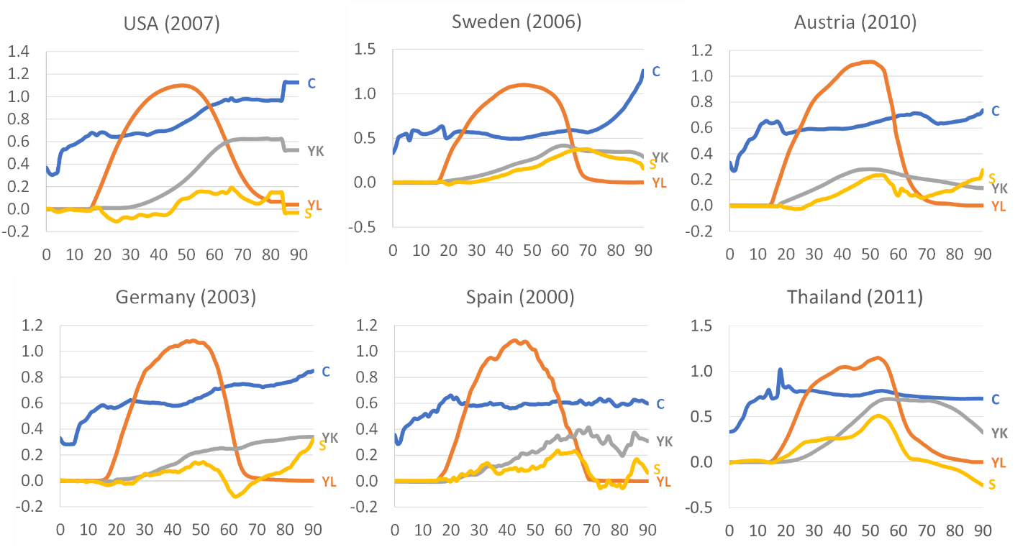

Figure 2. United States

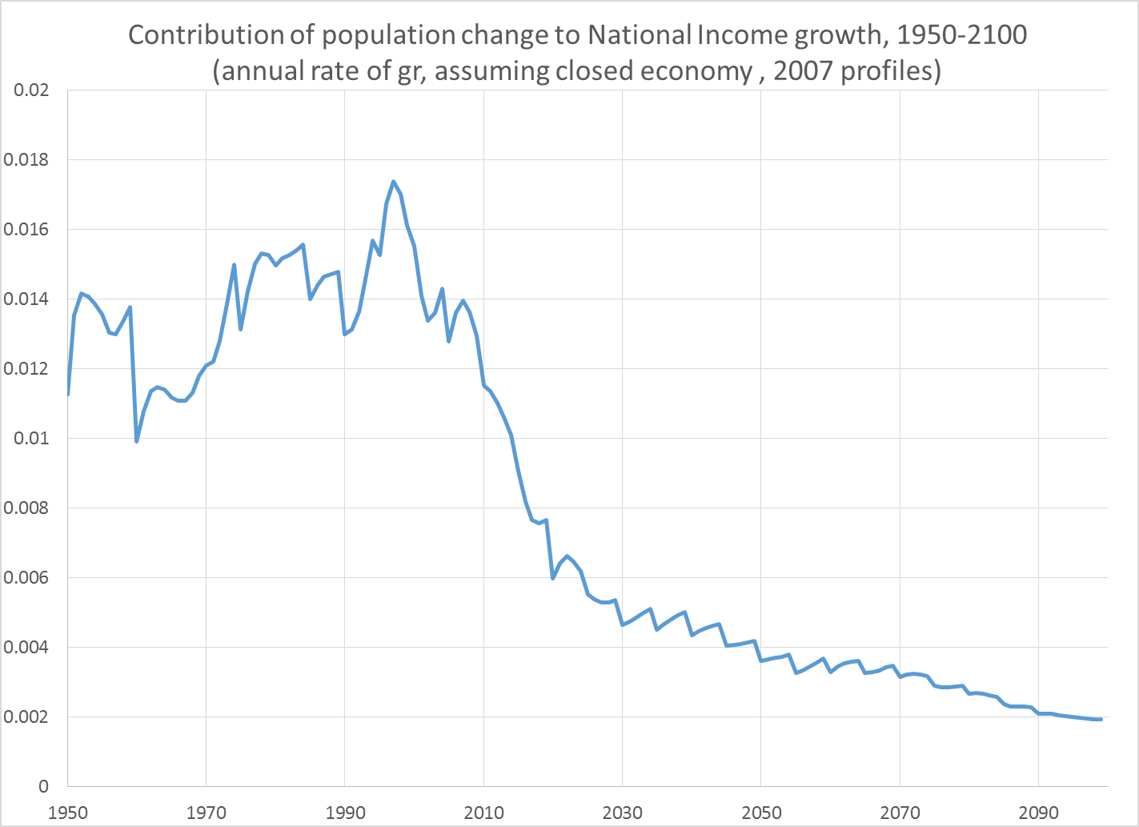

Figure 3.

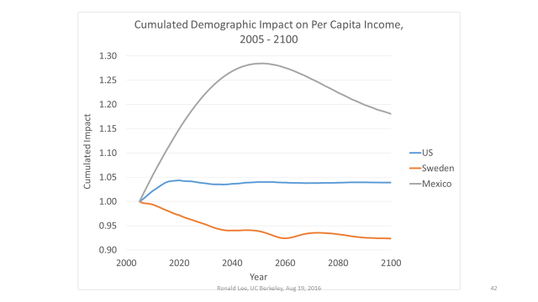

Figure 4. Simulated changes in the ratio of the wage to interest rate in 12 countries

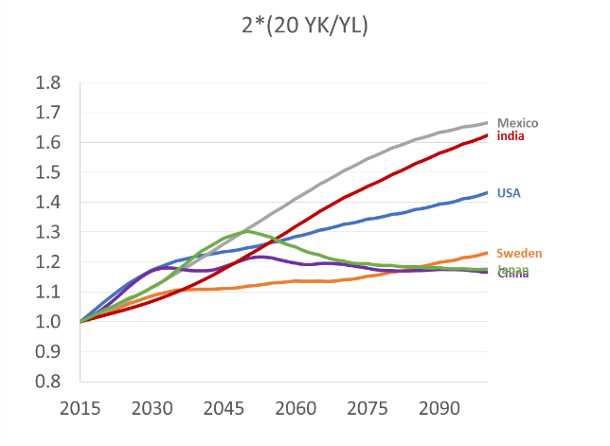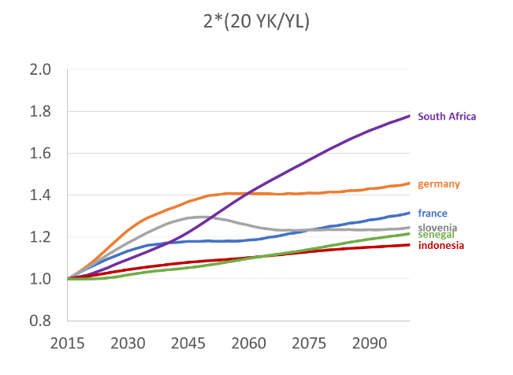

Figure 5. A Comparison of the Support Ratio (SR), Impact Index (for closed economies) and General Support Ratio (GSR) (for open economies) for nine countries (all indexed to 1.0 in 2015)

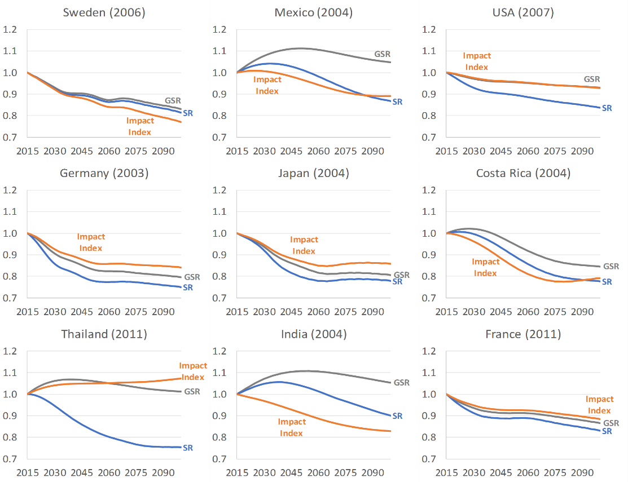

1. For the US, the appropriate r is .05. This is the average ratio of aggregate asset income to aggregate net worth from 1988 to 2010, where net worth is as reported by age in the Survey of Consumer Finance for various years.
2. Throughout, I do not distinguish between capital and assets. Asset income in NTA (and the System of National Accounts with which it is consistent) is the sum of capital income and net property income. Net property income includes the housing services of owned homes. Some might prefer to exclude housing capital from this measure, and I have also done the calculations for the US without including it. The results changed very little.
3. As explained later, there are at least four ways in which K has been related to demographic change in NTA studies, one of which is the approach I take here—to multiply the population age distribution times the age-asset income profile, times 1/r0 where r0 is calculated from data on asset income in relation to the value of the stock of assets, yielding about .05 for the US. The age-shape of the asset income profile has been quite steady over the past 35 years (since 1981). It is also possible to estimate the age profile of net worth using the Survey of Consumer Finance for the US, and its age-shape turns out to be remarkably stable since 1988. There is a systematic difference in shape between the asset income and net worth age profiles, but this can be traced to a different treatment of home owner’s equity when a mortgage is owed to a lender. Calculating K over the 21st century based on the age shape of the net worth profile and population projections gives a result very similar to the one here based on the asset income age profile.
4. In many US government surveys, to protect confidentiality age detail is not given after age 85; there is an open age interval of 85+, which we see in Figure 1.
5. There are at least four ways to model capital accumulation based on NTA data. Dynamic use of savings rates is one, and use of asset ownership by age (as done in this paper) is another. A third approach assumes that saving and asset accumulation is adequate to fund consumption at all ages consistent with the baseline NTA age-shape of consumption, given the context of public and private transfers by age. A fourth approach is to embed key data from the NTA profiles in general equilibrium OLG models with endogenous saving, consumption and asset accumulation, in response to changing mortality and endogenous interest rates.